- Write an R program to create and display a 3D array with specified rows, columns, and tables.

Aim:
To write an R program to create and display a 3D array with specified rows, columns, and tables.
Procedure:
Step 1: Open RStudio or R console on your computer.
Step 2: Create a sequence of numbers to be stored in a variable.
Step 3: Use that sequence to create a multi-dimensional array by specifying dimensions such as number of rows, columns, and tables.
Step 4: Store the created array in a variable.
Step 5: Display the array to view all the elements arranged across multiple rows, columns, and layers.
Step 6: Observe how an array in R can store data in more than two dimensions, unlike a matrix
Program:
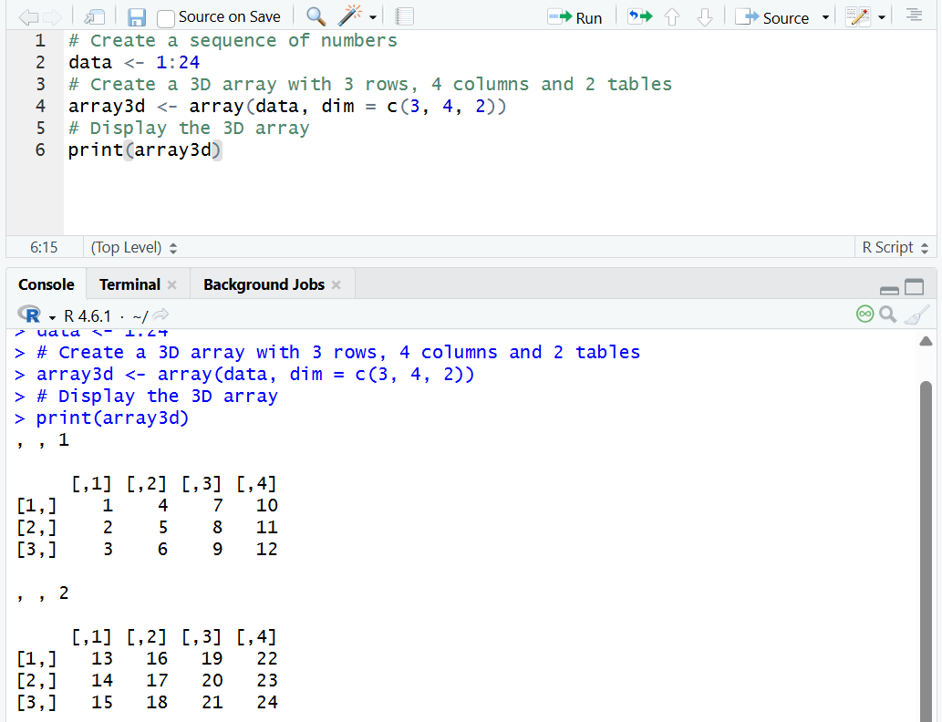
Result:
Hence the output is verified successfully.

